WEEK 6

/*3. Develop a Java program to create a class Actor with id, name, no_of_movies,

no_of_years_exp. Calculate the average_performance for each of the actor and print

the name of the actor with highest average.*/

import java.util.*;

class Actor

{

String id,name;

int no_of_movies,no_of_years_exp;

float average;

void accept()

{

Scanner sc=new Scanner(System.in);

System.out.println("-----enter actor's details----- ");

System.out.println("enter id ");

id=sc.nextLine();

System.out.println("enter name ");

name=sc.nextLine();

System.out.println("enter no of movies done by actor");

no_of_movies=sc.nextInt();

System.out.println("enter no of years of experience");

no_of_years_exp=sc.nextInt();

}

void cal()

{

average=(float)no_of_movies/(float)no_of_years_exp;

}

void display()

{

System.out.println("-----actor's details----- ");

System.out.println("actor id :"+id);

System.out.println("actor name :"+name);

System.out.println("no of movies done by actor :"+no_of_movies);

System.out.println("no of years of experience of actor :"+no_of_years_exp);

System.out.println("average performance of actor :"+average);

}

public static void main(String args[])

{

Scanner sc=new Scanner(System.in);

System.out.println("enter no of actors");

int n=sc.nextInt();

Actor []obj=new Actor[n];

float highest=0.0f;

String highest_actor="";

for(int i=0;i<n;i++)

{

obj[i]=new Actor();

obj[i].accept();

obj[i].cal();

if(obj[i].average>highest)a

{

highest=obj[i].average;

highest_actor=obj[i].name;

}

}

for(int i=0;i<n;i++)

obj[i].display();

System.out.println();

System.out.println(" actor with highest average performance : "+highest_actor);

}

}

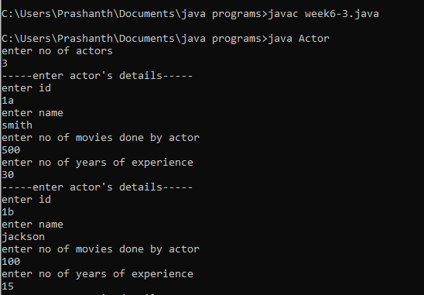

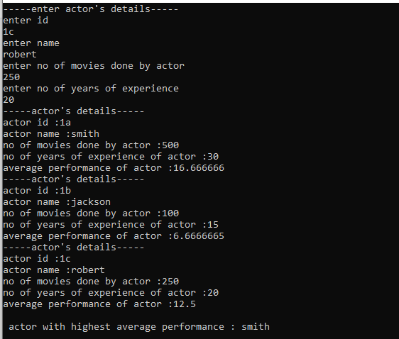

/*1. Develop a Java program to find the transpose of a given matrix of order MXN.*/

import java.util.*;

class transpose

{

public static void main(String args[])

{

Scanner sc=new Scanner(System.in);

System.out.println("enter rows and columns");

int r=sc.nextInt();

int c=sc.nextInt();

int a[][]=new int[r][c];

int b[][]=new int[c][r];

System.out.println("enter values ");

for(int i=0;i<r;i++)

{

for(int j=0;j<c;j++)

a[i][j]=sc.nextInt();

}

for(int i=0;i<r;i++)

{

for(int j=0;j<c;j++)

b[i][j]=a[j][i];

}

System.out.println("ORIGINAL MATRIX :");

for(int i=0;i<r;i++)

{

for(int j=0;j<c;j++)

System.out.print(a[i][j]+" ");

System.out.println();

}

System.out.println("TRANSPOSE MATRIX :");

for(int i=0;i<r;i++)

{

for(int j=0;j<c;j++)

System.out.print(b[i][j]+" ");

System.out.println();

}

}

}

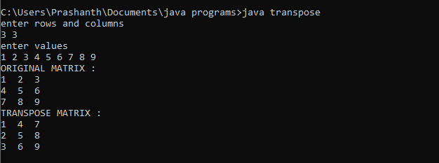

/*2. Develop a Java program which has the (only) class CircleDemo that has members-

radius, area and perimeter. Include methods to do the following.

a. accept the radius from the user

b. find the area of the circle

c. find the perimeter of the circle

d. Display all the details*/

import java.util.*;

class CircleDemo

{

double radius,area,perimeter;

void accept()

{

Scanner sc=new Scanner(System.in);

System.out.println("enter radius of circle");

radius=sc.nextDouble();

}

void find_area()

{

area=3.14*radius*radius;

}

void find_perimeter()

{

perimeter=2*3.14*radius;

}

void display()

{

System.out.println("area of circle = "+area);

System.out.println("perimeter of circle = "+perimeter);

}

public static void main(String args[])

{

CircleDemo obj=new CircleDemo();

obj.accept();

obj.find_area();

obj.find_perimeter();

obj.display();

}

}

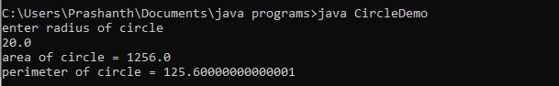

/*4. Develop a Java program to accept the values of a double array through command line.

Display the sorted array.*/

class sorted

{

public static void main(String args[])

{

double a[]=new double[args.length];

for(int i=0;i<args.length;i++)

{

a[i]=Double.parseDouble(args[i]);

}

System.out.println("original array:");

for(int i=0;i<a.length;i++)

{

System.out.print(a[i]+" ");

}

System.out.println();

double temp=0.0;

for(int i=0;i<a.length;i++)

{

for(int j=0;j<a.length-1;j++)

{

if(a[j]>a[j+1])

{

temp=a[j];

a[j]=a[j+1];

a[j+1]=temp;

}

}

}

System.out.println("sorted array:");

for(int i=0;i<a.length;i++)

{

System.out.print(a[i]+" ");

}

}

}

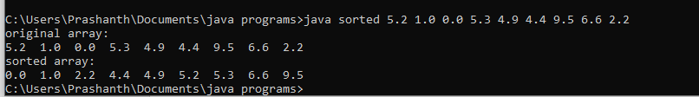

/*5. Design a Java program to accept a double array- Full. create two more arrays pos,

neg. Check every element of Full array and push the positive

numbers to pos array and negative numbers to neg. Count the number of

positives, negatives and zeros and display.*/

import java.util.*;

class pos_neg

{

public static void main(String args[])

{

Scanner sc=new Scanner(System.in);

int x,p=0,n=0,z=0;

System.out.println("enter array size ");

x=sc.nextInt();

System.out.println("enter values ");

double a[]=new double[x];

for(int i=0;i<x;i++)

a[i]=sc.nextDouble();

System.out.println();

for(int i=0;i<x;i++)

{

if(a[i]==0)

z++;

else if(a[i]>0)

p++;

else

n++;

}

double pos[]=new double[p];

double neg[]=new double[n];

int pp=0,nn=0;

for(int i=0;i<x;i++)

{

if(a[i]==0)

continue;

else if(a[i]>0)

pos[pp++]=a[i];

else

neg[nn++]=a[i];

}

System.out.println("no of zeroes in array :"+z);

System.out.println("no of positive numbers :"+p);

for(int i=0;i<p;i++)

System.out.print(pos[i]+" ");

System.out.println();

System.out.println("no of negative numbers :"+n);

for(int i=0;i<n;i++)

System.out.print(neg[i]+" ");

}

}

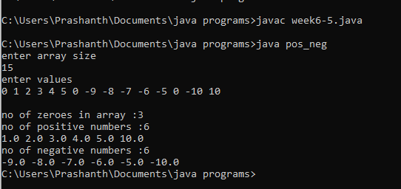

/*6. Design a Java program to accept a string. Count and display the number of

vowels, consonants and spaces in the string*/

import java.util.*;

class str_count

{

public static void main(String args[])

{

Scanner sc=new Scanner(System.in);

String s;

int v=0,con=0,sp=0;

System.out.println("enter a sentence ");

s=sc.nextLine();

s=s.toLowerCase();

char c;

for(int i=0;i<s.length();i++)

{

c=s.charAt(i);

if(c==' ')

sp++;

else if(c=='a'||c=='e'||c=='i'||c=='o'||c=='u')

v++;

else if(c>=96&&c<=122)

con++;

else

continue;

}

System.out.println("no of spaces : "+sp);

System.out.println("no of vowels : "+v);

System.out.println("no of consonants : "+con);

}

}

